Breaking Bad 107 script
请扫描下方二维码，关注公众号“非主刘”，有更多美语学习和其他精彩内容。


DEA Officer:In closing, I can tell you we take this very seriously.APD as well as the DEA.Stopping the manufacture and sale of methamphetamines remains one of our highest priorities.And the theft of lab equipment from your school is also receiving our highest attention.Rest assured, no stone will go unturned in our search for the person or persons responsible for this.If you have any questions, now would be the time.
In closing:最后；take this very serious.：严肃对待；manufacture:生产
DEA:Drug Enforcement Administration(美国)缉毒局;priority:优先;APD: Albuquerque Police Department
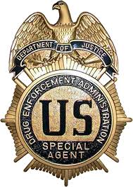
；leave no stone unturned:翻个底儿掉也要找出来（某人/物）

Parent:You're talking like you haven't caught anybody yet.What about the janitor that was dealing drugs at the school?
Carmen:There is no indication that this individual was selling drugs.He was arrested for having a small amount of marijuana in his car, not in the school.And he's since been fired.
Parent:I heard he had a record.I'd like to know how he got a job here in the first place.
in the first place:起初

Parent 2:Why wasn't there a background check?
background check:背景调查

Carmen: There was one.We're currently reviewing our hiring policies.
Parent2 :You better be doing more than that.He was arrested in front of my daughter.
Parent:This guy was stealing the lab equipment, right?
DEA Officer:That's not our thinking at this time.We are looking at others who had access, not limited to the maintenance staff.
maintenance staff:维修（维护）人员

Parent2 :Are you saying there was a break-in? Do we know exactly when this happened? I mean, could it have been during school hours?
DEA Officer:We haven't been able to establish a date or time, but there is no sign of breaking or entering.
Parent:So,Whoever took it had a key? We're talking inside job? Someone who's still at the school?
DEA Officer:Sir, At this time I'm not able to discuss the details, but what I can tell you is that we have some very good people working very hard on this case.
Parent:I'm sorry, Officer.But that sounds like double-talk.
Parent 2:We're trying to protect our children.You have to level with us.
Carmen:Really, we are giving you all the information we have.
Parent:You know what I'd like to see in this school? Drug-sniffing dogs(人人影视、搜狐视频给错英文字幕，给的是Grugs never does)
drug-sniffing dogs:缉毒犬

Parent 2: Yeah, dogs, and metal detectors, and locker searches, and strip searches.
metal detector:金属探测器
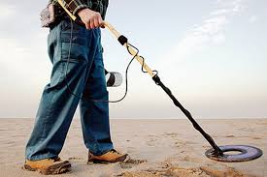
strip search:光身搜查

Carmen:Our district has strict policies
Parent 2: I heard about this school in Canada.They arrested one of their groundskeepers with drugs.And the next day they found out over half of the students were high on LSD.LSD? When were you gonna tell us about the LSD? No.Please.No one said anything about LSD.What about the equipment that was stolen?
groundskeeper:运动场场地管理员
high:嗑药嗑高了；LSD：迷幻药，是药理学上对迷幻药物、游离药物和谵妄药物的统称。这类精神药物产生的作用主要是改变人的知觉、思维、情绪以及意识。最根本的致幻剂是迷幻药物，游离药品让人产生无痛麻醉感、记忆缺失乃至昏厥感受，致谵妄药则是使人陷入癫狂状态
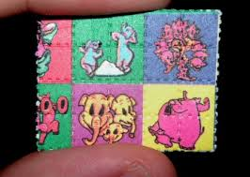迷幻药纸

Carmen:The equipment was taken from our chemistry department.And I would like someone to give us some specifics.Walt?
Walt:Yeah.
Carmen:Mr.White is currently on medical leave.But as he's chair of the science department, he's made a very special effort to be with us here.And I'd like to take a moment to thank him for that.Could you please tell us more about the equipment that was taken? - Please.
Walt:Yes.And thank you.The inventory list for the missing labware is as follows: one 5,000 milliliter round bottom boiling flask, one Kjeldahl-style recovery flask, two full-face respirators, some sep funnels, a still head(人人影视、搜狐字幕给错英文sill head) with a thermometer holder
labware:实验室器具
sep funnel= Separatory funnel:分液漏斗
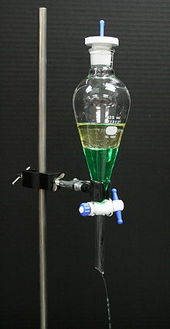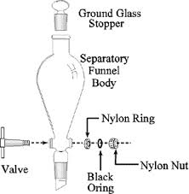
still head:分馏头
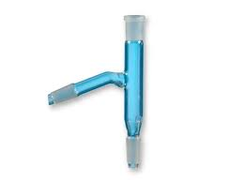

Skyler: Ow, my knee.Where did that come from? And why was it so damn good? Walt:Because it was illegal.
House Agent:The basement.Unfinished, of course.But just look at all this space.You gotta think rec room, media room.Just imagine all the things you could do down here.Now remember, you're buying for this fantastic neigorhood.Big lawns and shade tress.Walking distance to the country club.
rec room= recreation room [亦作rec hall]

Buyer:What happened there?
House Agent:Bit of a fixer, but this house has great bones.You know what? We're zeroing in.I've got another listing, brand-new, right around the corner.
Walt:Hi.
House Agent:Hi.It's by appointment only.
Walt:I'm here to see the owner.
House Agent:He's in the recreational vehicle.
Pink:Yo, it's appointment only!
Walt:How you feeling?
Pink:About as good as you look.Jeez, you look like Lex Luthor.
Walt:Listen, I visited you in the hospital, but you were asleep.
Pink:Yeah, Skinny Pete said you wanted Tuco's address.Acting like you were all out for blood.You are alive, so obviously you wised up.
Walt: No, I did go see him.
Pink: Bullshit.
Walt:Are you selling your house?
Pink:I got two dudes that turned into raspberry slushie and flushed down my toilet.I can't even take a proper dump in there.The whole damn house has got to be haunted by now.You didn't actually go see Tuco?
raspberry slushie：冰沙
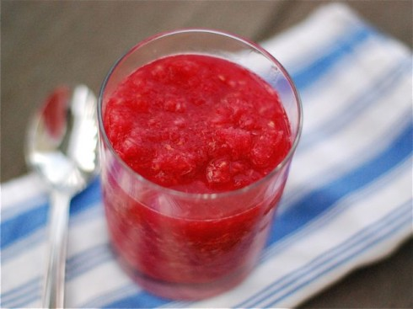
take a dump:大便; haunt:闹鬼

Walt:Here.That is seventeen-five.Your half of the 35,000.Plus there's an extra 15 in there.
It's all yours.You've earned it.
Pink:You got this money from Tuco.
Walt:Yeah.
Pink:So Tuco gave you this is what you're saying.
Walt:We made a deal.
Pink:You made a deal?
Walt: That's right.
Pink:Wait.Why would you make a deal with that scumbag? You see what he did to me?
Walt:Because I think that we can do business together.We came to an understanding.
Pink:No way, man! Okay? No understanding.
Walt:Take a look at the money in your hand.Now just imagine making that every week.That's right.Two pounds a week.3500 a pound.
Pink:Without even talking to me, you told this insane ass clown dead-eyed killer that, uh that we would give him two pounds a week?
Walt:We'll just scale up our operation. We'll add a few more hours
Pink:Don't talk to me about hours.What about pseudo, man? How are we gonna get that? You think the meth fairy is just gonna bring it to us? It takes me a week to get this stuff.I'm driving all the way out to Las Cruces.to meet up with my smurfs
smurf：做冰毒的人所雇用的去药店买药为了提取制毒原料的人，可译为“水军”

Walt:Smurfs?
Pink:Dudes who go to the drugstores and get a couple boxes at a time and then sell them to me.And that's maybe only good for, like, maybe a half-pound worth.See, that's the bottleneck in your brilliant business plan.
bottleneck:瓶颈

Walt:All right.
Pink:Of course you would have known that if you would have just asked me.
Doctor:Well, here we are again.
Skyler:Here we are.
Doctor: Skyler, you look great.
Skyler:Thank you.
Doctor:You must be, what, six, seven months? How goes it?
Skyler:It's great other than waddling to the bathroom every five minutes.
Walt:The baby shower's next week.It'll be good to It'll be good to have a day that's just about Skyler.
Doctor:Very nice.
Walt:Thank you.
Doctor:Well, Walt, I see you've committed to the hair loss.
Walt:Yeah.
Doctor: How do you feel?
Walt:Oh, okay.You know, pretty decent actually.
Skyler:His color is better.You know, his energy.And he's even more physical.
Doctor: More physical?
Skyler:Well sexual.Frisky, actually.I mean, that's got to be a good sign, right?
Doctor: Sure, I'll take that.Right, Walt?
Skyler:Couldn't that mean that the chemo is working?
Doctor: Realistically, it may just mean that we've got the anti-emetics tuned right.Truth is, until Walt's finished this round of chemo and we look at a new PET scan, we just can't say for sure.
PET scan: 正电子发射断层显像(Positron Emission Tomography); 电子发射计算机断层扫描（简称PET）是一种核医学成像技术，它为全身提供三维的和功能运作的图像。正电子发射计算机断层扫描既是医学也是研究的工具。在肿瘤学临床医学影像和癌扩散方面的研究方面有着大量的应用。是核医学领域最先进的临床检查影像技术。PET技术是目前唯一的用解剖形态方式进行功能、代谢和受体显像的技术，具有无创伤性的特点，是目前临床上用以诊断和指导治疗肿瘤最佳手段之一
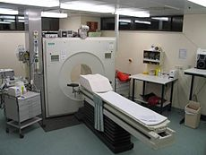
Skyler:Isn't there anything else we could be doing? I've been wondering about alternative medicine.I mean, Eastern healing.You know, holistic.
holistic: 整体观医学的; 整体观是中医学关于如何看待人及其健康和疾病的一个基本观点。认为人体是一个有机的整体，构成人体的各个组成部分之间，在结构上是不可分割的，在功能上是相互协调、相互为用的，在病理上是相互影响的。同时认为，人类生活在自然界中，人体的生理功能和病理变化，不断地受自然界的影响，人类在能动地改造和适应自然的斗争中，维持着机体的正常生命活动

Doctor: Well, I can't speak to its efficacy.But as long as it doesn't interfere with our treatment, anything that helps my patient have a better outlook, a better comfort, is fine by me.
Skyler:So you're saying it's all psychological.It doesn't make any real difference.
关注微信公众号“非主刘”，有更多美语学习和其他精彩内容。

Doctor: Having a better outlook can make a tremendous difference.But it's also important that we manage our expectations.
Walt:What?
Pink: A junkyard? Let me guess, you picked this place?
Walt:What's wrong with it? It's private.
Pink:This is like a non-criminal's idea of a drug meet.This is like, "Oh, I saw this in a movie.Oh, look at me.
Walt:" So where do you transact your business? Enlighten me.
Pink:I don't know.How about Taco Cabeza? Half the deals I've ever done went down at Taco Cabeza.Nice and public.Open 24 hours.Nobody ever gets shot at Taco Cabeza.
Hell, why not the mall? You know, wait at the Gap."Hey! It's time for the meet." You know, I'll put down the flat-front khakis, head on over, grab an Orange Julius.Skip the part where psycho lunatic Tuco comes and steals my drugs and leaves me bleeding to death.
Walt:Look, you don't have to be here for this.Okay? I mean, seriously.I'm okay.
Pink:Nah, I'm no pussy.I'm good.
Tucco:Mr.Clean and his boy.I'm sorry that I had to tune you up.Respect, ese.You gotta give it to get it.Hey, what are we doing way the hell out here? What, they close the mall or something? Heisenberg, come on, break it out.That's it? That's all you got?
Mr.Clean:美国的清洁剂（威猛先生，喻指Walt光头）
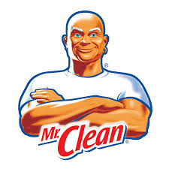

Walt:We had some production problems.
Bitch 1:Point five-three.
Tucco:I thought you was a player.You told me two pounds, and now you waste my time with these Chiclets? minus the half for wasting my time.

Walt:Hey, come on.
Tucco:What, you're gonna argue? You got something to say? You're doing business like a couple little bitches.
Walt:I want all of it.70 grand
Tucco:What did you say?
Walt:You like this product, and you want more.Consider it a capital investment.
capital investment：资本投资

Tucco:Loco bald motherfucker.52 and a half,0.25 points vig
Walt:Vig?
Pink:Interest.Weekly.
Walt:Okay.
Walt:That's $65,625 with interest.1.875 pounds.
Tucco: No.2 pounds,Next Friday.And no production problems.
Walt:Can you handle 4 pounds?
Tucco:Listen, old man.Talk is talk.But owing me money that's bad.
talk is talk：说归说

Pink:What did you just do? 4pounds as if 2pounds wasn't bad enough.We're talking 200-300 boxes of sinus pills.There ain't that many smurfs in the world.
sinus pills:鼻窦炎药

Walt:We're not going to need pseudo ephedrine.We're going to make phenylacetone in a tube furnace, then we're gonna use reductive amination to yield methamphetamine, 4 pounds.
phenylacetone: 苯基丙酮;
苯基丙酮：为黄色液体，不溶于水，溶于醇、丙酮、苯等有机溶剂。由苯乙酸与乙酐反应而得。在化学研究当中，有许多的方法可以制备合成苯基丙酮。
其中较为简单的方法是使用苯与氯丙酮发生傅－克反应制备。苯基丙酮属一级易制毒化学品,受公安部门管制。
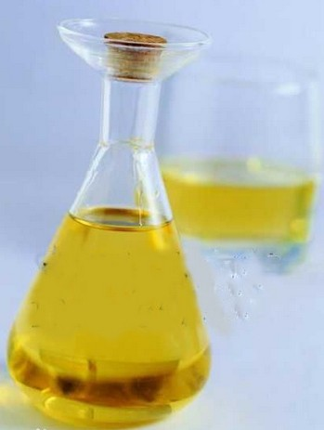

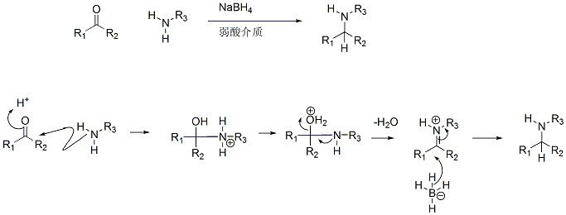
Pink: So no pseudo?
Walt: No pseudo.
Pink:So you do have a plan.Yeah, Mr.White! Pink:Yeah, science!
Walt:Okay.
Pink: What's this?
Walt:That is a shopping list.Getting some of those items may be challenging.
Pink:"One autotransformer,6 liters hy hydrous methyl methylamine, two 35 M&M tube furnaces"
autotransformer: 自耦变压器; 同容量的自藕变压器与普通变压器相比，不但尺寸小，而且效率高，并且变压器容量越大，电压越高．这个优点就越加突出。因此随着电力系统的发展、电压等级的提高和输送容量的增大，自藕变压器由于其容量大、损耗小、造价低而得到广泛应用。由于自耦变压器供电方式非常适用于大容量负荷的供电，对通信线路的干扰又较小，因而被客运专线以及重载货运铁路所广泛采用。早期中国铁路专用自耦变压器主要依靠进口，成本较高且维护不便。由中铁电气化局集团保定铁道变压器有限公司设计并生产的OD8-M系列铁路专用自耦变压器先后在神朔铁路、京津城际高速铁路、大秦铁路重载列车单元改造、武广客运专线等多条重要铁路投入使用，受到相关部门的高度好评，填补了国内相关产品的空白。
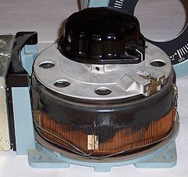
hydrous Methylamine:水溶液 甲胺 ；甲胺是一种有机化合物，化学式CH3NH2，它是氨中的一个氢被甲基取代后所形成的衍生物。市售品一般是其甲醇、乙醇、四氢呋喃或水溶液，或作为无水气体在金属罐中加压储存。工业品常将无水气体加压后通过拖车运输。它有很强烈的鱼腥味。甲胺被用作合成很多其他化合物的原材料，每年大约能生产上亿千克。甲胺也是美国缉毒署（DEA）列在第一类的化合物（作为生产毒品甲基苯丙胺的前体）
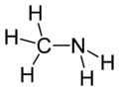
Walt:That's MM: millimeter.One 70-millimeter would be fine, but they're hard to come by, so
Pink:"40 grams thorium nitrate"? Yo, Mr.White, I can't even pronounce half this shit.You know what? Count me out.I'm leaving town.I'm moving to, like, Oregon or something,
Walt:Jesse, Jesse, listen to me.Today is the first day of the rest of your life.
Pink:What are you doing?
Walt:This is the first day of the rest of your life, but what kind of life will it be? Will be be a life of fear, of "Oh, no, no, no, "I can't do this," of never once believing in yourself?
Pink:I don't know.
Walt: Listen.These things? We need them.
And only you can get them for us.
Walt Jr:Okay, it's ready.There you go.
Marie:Hi, baby.I'm your Aunt Marie.Now, you already know that because when you watch this 20 years from now, I will look exactly the same as I do now.I know it is amazing.I have aged shockingly well, haven't I? Anyway, welcome to your baby shower, Esmeralda!
baby shower: 迎婴聚会（baby shower） 是美国一个传统活动。怀孕妇女在临产前一两个月的时间内，她的女性朋友为她举办一个派对, 迎接宝宝的诞生。

Walt Jr:Esmeralda?
Marie: Esmeralda.That's your name, and you heard it here first.Now, that is your wonderful, handsome older brother.Show her, older brother, your face.Okay.Not right up the nose.
Not Back to me.There's your mommy! Hello, Mommy! And look! There you are, Esmeralda! Wake up, baby! Time to party!
Skyler: Easy.Believe it or not, Esmeralda, right after the party, your name was changed to Holly.And I believe, Hank, that that was around the time that we took Aunt Marie to the insane asylum.
Hank:Yeah, yeah.I dropped her off at the curb.Then I married Shania Twain and lived happily ever after.
Marie: There's Daddy! Speak, Daddy! Say hello to your daughter.
Walt: Holly, I am very proud of you, and I think about you all the time.Wherever you go, whatever you do in life, always know that you have a family who loves you very, very much. Cheers.Cheers!
Skyler: Oh, my God, it's so cute.Oh, Carmen, it's Oh, look.Look at that.It's adorable.I love it, Carmen.Thank you.
Carmen:You're so welcome, honey.
Skyler: Thank you.Look at the little feet.
Marie: From me.And Hank.
Skyler: What nice wrapping paper.Marie always finds the best wrapping paper.
wrapping paper:包装纸

Marie: I do.
Skyler: Okay.Let's see what this is.Exciting.Oh, boy, oh, boy, oh, boy, oh, boy.It's a a tiara.Marie, is this
tiara: 女式冕状头饰

Marie: White gold and several carats' worth of zircons.
Skyler: Oh, Marie, you spent too much on this.You shouldn't have.You really, really shouldn't.But it's so It's really It's sparkly.Sparkly! Like wow! Thank you.
Hank:Hey, listen, Walt You got anything stronger than beer?
Skyler:It's just gor Oh, it's great.I love it.Thank you.
Thank you, sweetie, thank you.
Hank:Sorry, man.You know, after 200 presents, it just gets kind of old.That's nice stuff.
Walt: It is, isn't it?
Hank:I got just the thing to go with that.I'm sorry.I wasn't thinking.
Walt:No, no, no, no.It's okay.You mind if I have one?
Hank:You think it's a good idea?
Walt: Hank, I've already got lung cancer.
Hank:Okay.You got me there.
You got me there:被你打败了

Walt:Thanks.Cuban.
Hank:I did a little favor for an FBI guy.
Walt:Now, I was under the impression that these were illegal, hmm?
Hank: Yeah, well, sometimes forbidden fruit tastes the sweetest, doesn't it?
Walt:It's funny, isn't it? How we draw that line.
Hank:Yeah? What line is that?
Walt:Well, what's legal, what's illegal, Cuban cigars, alcohol.You know, if we were drinking this in 1930, we'd be breaking the law.Another year, we'd be okay.Who knows what will be legal next year?
Hank:You mean like pot?
Walt:Yeah.Like pot.Or whatever.
Hank:Cocaine? Heroin?
Walt:I'm just saying it's arbitrary.
It's all gonna be legal next year when Willie Nelson's president." Shit, buddy, it doesn't only go one way, either.Sometimes there's stuff that's legal that shouldn't be.I mean, friggin' meth used to be legal.Used to sell it over every counter at every pharmacy across America.Thank God they came to their senses on that one, huh?

Walt: Yeah.Nice party.
Skyler: A tiara.A white gold tiara for a newborn baby.Yeah.You know, I think she got that at Gertrude Zachary's in Nob Hill.I mean, that thing must have cost, like, what, $500 or $600.You know what? I think I'm going to return it.
Gertrude Zachary:珠宝品牌
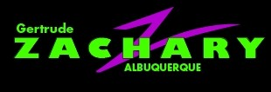
Walt: You sure? She's bound to find out.
Skyler: Well, maybe I can explain to her that we need a Diaper Genie more than a white gold baby tiara.
Walt: You know, I've been thinking about what you said to Dr.Delcavoli about alternative medicine.
Skyler: Don't worry.I'm not going to mention that anymore.
Walt: What I mean is that maybe there is something to it.Here.Look.They do this Navajo sweat lodge up by Farmington.Healing ceremony.It's supposed to be good for your lungs.I'm not saying that I believe in it, but you know, it might be an experience.

sweat lodge:蒸汗屋
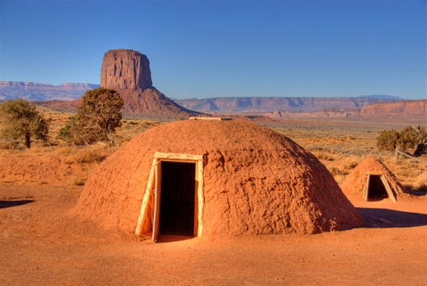
do up:装修；修缮；Farmington：新墨西哥州城市-法明顿

Skyler: Really? You? In a sweat lodge?
Walt: I was thinking about driving up on Friday, coming back Sunday.I mean, if you're okay with it.
Skyler: Well, of course I'm okay with that.
Walt:Okay.
Pink: Sweat lodge?
Walt: Yeah.
Pink:I'm already sweating.Help me out Okay.
Walt:Right.70 millimeter tube furnace Excellent.This is excellent.Very good work.
Pink: Damn straight.
Walt:Okay.Hydrogen.Electrolytically
produced, yes?
Pink:Yeah, like you asked.I mean, this crap wasn't easy to get.It was expensive.
Walt:Methylamine.Where's the methylamine? I don't see the methylamine.
Pink:Yeah, well, that's where I ran into some trouble.
Walt:What kind of trouble?
Pink: Well, half this crap I could just buy, right? But this methylamine not so easy.They got it locked down tight.But I did find some pros who will rip it off for us.But they want 10 grand.
Walt:So what's the problem? You have the money.
Pink:No, had.I already spent almost the whole wad.I mean, I got, like, 2 grand left.
I told you, all this crap was expensive.
Walt:So these thieves, did they say where they would be stealing it from?
Pink:Yeah, a chemical supply place south of town.They got guards and security cameras, big ass steel doors.That's why these dudes are charging so much.What?
Walt:So why don't we just steal it ourselves?
Pink:Yeah? How are we going to do that? Walt:With this.
Pink:So what's this stuff called again?
Walt:Thermite.
thermite:铝热剂
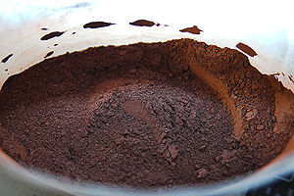
铝热法，是用铝粉还原金属氧化物获得金属单质的方法。反应剧烈放热，温度可达2500°C，并发出耀眼的光芒。生成物为氧化铝和该高熔点金属的单质。铝热剂(thermite)指铝和金属氧化物的混合物，一般指铝和氧化铁的混合物（比例约为1:2.95）。将铝粉和一定量的高熔点金属氧化物（如氧化铁等）混合后，用镁条引燃。生成物为氧化铝和该高熔点金属的单质。德国化学家汉斯·歌德史密斯于1893年发明铝热法并于两年后申请专利。因此该反应也被称为“歌德史密斯法”。研究最初的目的是在不用碳熔炼的条件下制备高纯度金属，但歌德史密斯敏锐的发现铝热法可以用于焊接。1899年在德国埃森，铝热法首次商业应用于焊接铁轨。铝热反应过程中放出的热可以使高熔点金属熔化并流出，故铝热法广泛运用于焊接抢险工程之中。另外，铝热法也是冶炼钒、铬、锰等高熔点金属的重要手段。因为反应温度极高，用于制作燃烧弹，可熔穿装甲。

Pink:And that will cut through a lock? Because this is supposed to be one big ass lock.
Walt:In World War II, the Germans had an artillery piece, it's the biggest in the world, called the Gustav Gun, and it weighed a thousand tons.And the Gustav was capable of firing a 7-ton shell and hitting a target accurately 23 miles away.I mean, you could drop bombs on it every day for a month without ever disabling it.But you drop a commando, one man, with just a bag of this and he could melt right through and destroy that gun forever.

Pink:Jeez! So yes.
Walt:So yes,I think it will cut through any lock we're likely to find.
Manager:You'd like to return this?
Skyler: It's very nice, but yes.Well, it is from the store, isn't it?
Manager:Oh, yes.It's from this store.Do you happen to have a receipt?
Skyler: No.I don't.It was a gift.
Manager:A gift.Mr.Wilson, could you step over here, please? Mr.Wilson, I'd like you to watch this lady while I phone the police.
step over:向…靠近些

Skyler: Excuse me?
Manager: Ma'am, this item is stolen, as I'm sure you know.Come with me, please.Oh, yes.
I intend to press charges.Please do.We'll be here.
press charges:正式控告
关注微信公众号“非主刘”，有更多美语学习和其他精彩内容。

Skyler: Look, I I've never stolen anything in my life, all right? I told you.That tiara was a gift.A baby shower gift.
Manager:So who gave it to you, then?
Skyler: I don't think I have to tell you that.
Manager: You don't have to tell me anything.You can talk to the police, and I can tell them how my daughter-in-law remembers showing this particular item to a tall blonde woman who, when her back was turned, walked right out the door with it.So there.
Skyler: Oh, yeah? Then I can talk to the Channel 3 News.Yeah.I can tell them how you people, without a shred, without a modicum of evidence, illegally detained an innocent pregnant woman in a dank storeroom.
Manager: This is my office.
Skyler: I feel I'm being held hostage.Furthermore, I'm not getting enough air back here.I don't think I can breathe.Oh, my God.Oh, no.I'm going into labor.Yes, I
(on the phone)Marie: Hi.You've reached Marie.Do the beep thing.
Skyler: Marie? It's Skyler.I just left Zachary's.
Pink:I need to talk to you immediately.
Walt:Where's the guard? He's supposed to be coming by.You think he already passed?
Pink:I don't know.There he is.
Walt:Yeah, I see him.
Pink:Wait till he passes.Okay, it's clear.What the hell is this?
Walt: It's all they had.
Pink:Then you go to another store.If this is all they had, wrong place.
Walt:Just put it on.
Pink:Of course you can Okay.This is it.
Walt:Oh, God.Dawm.
Pink:Where Duck.Duck.
Walt:What?
Pink:He's not supposed to come back.What's he doing?
Walt:Oh, God.
Pink:He's going to the crapper.
Walt:Oh, God. Carry your bag.
Pink: What? What are you doing? Okay, there is it.Is this going to be loud?
Walt:We'll find out in about ten seconds.Stand back.
Pink:Jesus!
Security:What's going on?
Walt:Where are the gallon jugs?
Pink:I don't know.
Walt:God! –
Pink:What?
Walt:Let's just take this.Come on.Come on.What the hell are you doing opening the door?
Pink:How are we going to take this thing out? Come on Let me try.
Walt:How is it going to be any different?
Pink:Can I just try it?
Walt:Fine, fine, go ahead.
Pink:Jesus.Okay.
Walt:All right.
Pink:Yeah, baby.See? Eat it, okay? I'm the king.I'm the king.No, no, no.That didn't sound good.
Walt:Well, this thing's not going anywhere.
Pink:We're not cooking in my damn driveway.I tell you that.
driveway: （从建筑物，住房，车库等通往大路的）私人车道
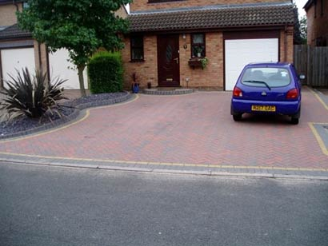
Walt:What part of slow it down did you not understand?
Pink:You talk too much.It's heavy, man.You got to wait for me.
Walt:Okay.That's good, that's good.Now just bring it up.Easy, easy, easy.Okay.Your real estate agent, when is she supposed to come back?
Pink: Shit.Yo, I don't know.I'll make damn sure she doesn't.Good call, yo.All right.
Good call:说的好

Walt:Keep the temperature steady at 425 degrees.We'll need to run it two more hours to have enough to make 4.5 pounds.
Pink:4 and a half,not 4?
Walt:2 pounds pays Tucco back,4.5pounds puts us $44,000 ahead each.
Pink:Right on, man.Right on.
Walt:With the amount of methylamine that we got last night, we could make 4.5 pounds a week for well, for the foreseeable future.
Pink:How long is that going to be? I mean in your situation.How much cash do you need?
Walt: More.
Pink:Someone's in my yard.
Walt:Was there, by any chance, scheduled for this afternoon an open house?
by any chance:万一；碰巧

Pink:I left them a message, man.It's not my fault.
Walt:I don't care how you do it.Just keep them out of here.Do you understand?
Pink: Yeah.
Walt:Go.
Skyler: You know you can't duck me forever.
Marie: What?
Skyler: Come on.I left you, like, 15 messages.When I went to your office, you snuck out the back way.
snuck(sneak过去式) out：溜出去

Marie:I didn't sneak.I was going to lunch.Jeez, Skyler, what are you, the paranoid police?
Skyler: Marie, I have never been so humiliated in my life.That tiara.They accused me at Zachary's of shoplifting it.
Marie:What were you doing at Zachary's?
Skyler: I was returning it.
Marie:You were returning it.Why would you return it?
Skyler: It just wasn't Marie, what is wrong with you? Can you please tell me that? Can you tell me why you'd do such a thing? What does that mean? Does that mean you don't know?
Marie:That means that I have no idea what the hell you're even talking about.
Skyler: You have no idea what I'm talking about.The shop The shoplifting.
Marie:No idea?
Skyler: You're not going to admit this, are you?
Marie: I can't really admit to something when I have no knowledge of what it is that I'm admitting.
House Agent:Don't forget to sign in.
Guy:Excuse me.I'd just like to see the basement.
Pink: Yeah, well, it's occupied.
Guy: It's not a bathroom.I just want to see the basement.What's the big deal?
Pink:Yo, you ain't seeing the basement, bitch.You got that? Is that sinking in(人人影视、搜狐视频给错中文字幕)? Now beat it.All of you all.House is not for sale.Get the hell out!
sink in:被理解；beat it:走开

Skyler:So how was it? Was it a an experience?
Walt:Yeah.It was definitely an experience.
Skyler:What's that smell?
Walt:Yeah.It's sacred Navajo herbs and Hey, is everything okay?
Skyler:No.Not really.Actually, not at all.You know that tiara that Marie gave us?
Walt: Yeah.
Skyler:Well, she stole it.Yeah.I practically got arrested trying to return it at the store.
Walt:Oh, my God.
Skyler:She refuses to admit it.She refuses to apologize.I don't know what to do.
Walt:Oh, well.People sometimes do things for their families.
Skyler:People sometimes do things for their families? And, what, that justifies stealing?
justify:证明…正当合法

Walt:Yeah.
Skyler:That must have been some sweat lodge.Have you been listening to the words coming out of your mouth?
Walt: What would you do if it were me?
Skyler: What do you mean if it were you?
Walt:If it were me, what would you do? Would you divorce me? Would you turn me in to the police?
Skyler:You don't want to find out.Do you want something to eat?
Walt: No, thanks.
Tucco:What is this shit? This is blue.
Walt:We used a different chemical process, but it is every bit as pure.
Pink:It may be blue, but it's the bomb.
bomb:超棒

Tucco:Tight! Tight, tight, yeah! Blue, yellow, pink.Whatever, man.Just keep bringing me that.
tight:超棒

Bitch 1:4.6
Tucco:Come on.And what did I say, man? This guy can cook! You're all right, man.You're all right.We're going to make a lot of money together.
Bitch 1:Just remember who you're working for.
Tucco:What did you say?
Bitch 1: I'm just saying they got to know that they're working for you.
Tucco:Like they don't already know that? Are you saying that they're stupid?
Bitch 1: No, I'm just I'm just saying.
Tucco:Oh, yeah.So you're not saying that they're stupid.So I don't understand.Are you saying that I'm stupid?
Bitch 1: No.Come on, Tuco.I'm just saying.
Tucco:No, you're just speaking for me! Like I ain't got the damn sense to speak for myself! Is that it? Is that what you're doing?
Walt:Tuco.Hey, why don't we all just relax, huh?
Tucco:Heisenberg says relax.Orale, homes.I'm relaxed.I'm relaxed.I'm relaxed.Damn, man! Look at that! Look! Yeah.That's messed up.Okay, Heisenberg! Next week.
mess up:搞砸了

