Breaking Bad 104 script
请扫描下方二维码，关注公众号“非主刘”，有更多美语学习和其他精彩内容。


Hank:Operation lcebreaker.How we liking
that? We never used that before, did we?
Gomez:lsn't it the name of a breath mint?
breath mint:薄荷糖

Hank:What?
Gomez:"lcebreakers", right? Breath mint?
Hank: Nobody's gonna be thinking
that.They'II think about a big ass ship in the
North Pole, breaking ice.
Gomez:Says you.l'rn gonna be thinking
"Operation Breath Mint”.
Hank:" l'm thinking "Operation Breath Mint"
every time we're on a stakeout together.Your
breath could knock a buzzard off a shit
wagon.AII right."Operation TBD." Thanks for
nothing, Gomie.Anyway.Say hello to Domingo
Gallardo Molina, AKA "Krazy 8." Smarter than
your average cheese-eater,l turned him out at
the street-level, but this dude's like the
Jeffersons: movin' on up.
the Jeffersons:1974年的情景喜剧，讲述一富裕的非洲裔美国人Jefferson夫妇的故事；
moving on up是这部剧的主题曲；move on
up：更上一层楼
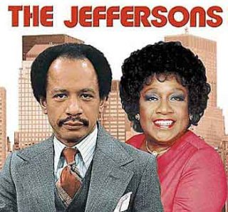

Gomez:Every small-time dealers he'd throw
at us, he'd end up snaking their customers

Hank:it turns out he's missing, presumed
dead.Found his car out in the boonies.Last
guy he ratted out was none other than his
cousin．Emilia Koyama.
Police:You thinking the cousin found out and
took revenge?
Hank: Could be.Turns out he's missing, too.
Normally, l'd say someone did the world a
favor.But our snitch's car? Turns out we find
two grams of meth in it, we take it to the lab.
They come back, they tell us it is the purest
they have ever seen.
Gomez:99.1%
Hank:Our chemist was blown away.He said
he couldn't do the same thing better.Worse
yet, it didn't come out of some superlab in
Mexico.We're thinking this was cooked right
here, in the Land of Enchantment.Car was
abandoned at what appears to be a cook site.
This is the only other thing left behind.We're
sending it off to Quantico, see if they can pull
something off it.Meantime, our guys swabbed
the filter element and found the same 99.1
meth.So be on notice.We got new players in
town.We don't know who they are, where
they come from but they possess an extremely high skill-set.Me personally? I’m
thinking Albuquerque just might have a new
kingpin,
filter element:滤芯
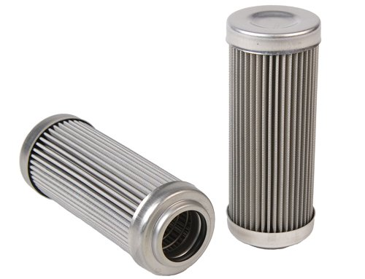

on notice:按事先通知地
possess:拥有；skill-set=全套技能
kingpin:关键人物

Hank:Jesus.Walt, you're burning the shit out
of them.
Walt:Damn it．
Hank:Hey, Sky, you got any more chicken?
Emeril here is gonna need a fresh pack.AII
right, looking good.
Emeril:美国一大厨，个人拥有13个餐厅。
也经常出现在电视上做料理节目。
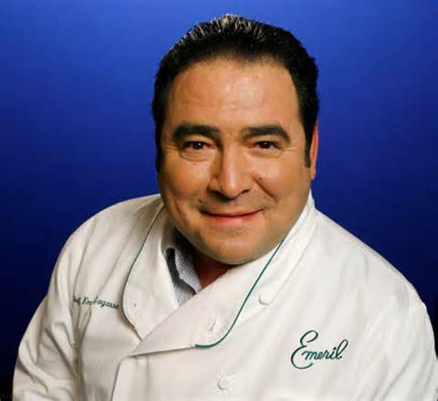

Marie:ls this low-fat mayonnaise in the cole
slaw?
mayonnaise:蛋黄酱；cole slaw:卷心菜沙拉

Skyler:I don't know.lt's store-bought.
store-bought:商店里买的，现成的

Walt:Hank, you need another beer?
Hank:Does the Pope shit in his hat?
Marie: I don't think that he does, Hank.And I
think everybody would like it if you'd stop
saying that.
Walt:Marie, some more wine, maybe?
Marie:l'm all right, thanks.
Walt Junior:Hey, I want a beer.
Hank:Yeah.l want Shania Twain to give me a tuggie.Guess what? That ain't happening,either
Shania Twain:（仙妮亚·唐恩）加拿大著名女
歌手，是当今乡村流行乐坛绝对的实力派天
后．是乡村音乐界当仁不让的一姐。她的第
三张原创专辑《Come on Over》(1997年)
在世界销量超过4000万张，是除《The
Bodyguard》外（有时该专辑也被视为电
影原声带）世界音乐史上女歌手销售最高专
辑。

tuggie:打手枪（飞机）；撸管儿；手活

WaIt:How about some more soda?
Walt Junior:Yeah, sure.
Walt:Honey, do you need anything?
Skyler:No, Walt.Thank you.
Walt:Okay.l'II be right back.
Hank:What, are you kidding me? You look
like a damn movie star, man.Girls gotta be
lining up left and right.Tell him how good-looking he is.
Marie:He's adorable.
Hank:He don't wanna be frigging adorable.He
wants to be hot.You see what l'm talking
about? That's a female perspective.
frigging=fucking=该死的, TMD; perspective:观点

Walt Junior:She supposed to say that
Hank:Look, a guy doesn't have to look Iike,
uh Charlton Heston l'm talking "Moses"
days to get a girl, all right? You just gotta have
confidence.Confidence and and persistence.
That's what l'm talking about.l chased your
Aunt Marie here all over creation.l kept
bugging her for a date.She kept saying no.
What, did I ask you like 50 times?
Charlton Heston:美国老牌男演员，《宾虚》
的男主角，《老友记笔记书》第四季有详细
介绍。
Moses:摩西（犹太人的古代领袖）

Marie:it was before they tightened the stalking laws.
Hank:Anyway, how about your dad here?
Right there's a good story, Walt.Tell him how
you met Skyler.
Walt Junior:Mom was a waitress in Los
Alamos.And Dad said that thing to you
Walt:Actually, your mother wasn't a
waitress.lt was a summer job, and she was
the hostess, and she also worked the cash
register.And I used to go in there a lot
because it was close enough to the lab where
I could ride my bicycle.And once I noticed her
it got to be so that I would only go in when I
knew she was working.When it was slow, she
would lean against the counter, doing her
crossword puzzles, but kind of hiding it, right,
pretending that she was still working.And
once I caught on to that, I would do crossword puzzles while I ate my grilled cheese sandwich.lt got so that everyday at
lunch, we would both be doing the New York
Times crossword puzzle ten feet from each
other.Eventually, I caught her looking over at
me.So, I began saying, "Excuse me."Fourteen
across, seven-letter word for
whatchamacallit. May I ask what you wrote
down?" That got us talking.Boy,I tell you,I
was I was terrible at those puzzles.l don't
think that I finished even one of them.But
your mother would do them in ink.Very
smooth.
hostess:女服务员；搜狐视频错误翻译为“女主人”（hostess和waitress的区别是，hostess是引座员，而waitress是负责点餐上菜的。）
slow:（经营）清淡的时候；
grilled cheese sandwich:烤芝士三明治
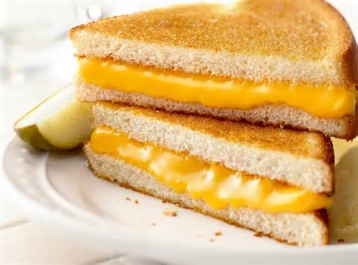
whatchamacallit= =what-do-you-call-it:你
怎么说
in ink:用钢笔写（不像铅笔写那样没把握，
喻指很有把握，很擅长）
smooth:做事做的漂亮
关注微信公众号“非主刘”，有更多美语学习和其他精彩内容。

Hank:i'll bet you didn't your old man had it in him? But that's what l'm talking about. That's persistence.You see? Once you set your cap for something, or somebody, you gotta just, you know Skyler?
Walt Junior: Mom, are you all right? Shh,
honey.
Marie:lt's okay.What's the matter? What is
it?
Skyler:Ask him.
Marie:What's she talking about? Walt.
WaIt:i have cancer.Lung cancer.lt's bad.
Skyler:Ask him how long he's known.
WaIt:l guess a month, maybe, or
Marie:For God sakes, Walt.We're just sitting
out there having a cookout like nothing's
going on?
cookout:户外做饭

Skyler:He made me promise not to tell
anybody.Christ, these last 48 hours.And it's
the weekend, so I couldn't even get his doctor
on the phone.
Hank:Buddy, why I mean, why wouldn't you
want to tell anybody?
Skyler:Walt,Don't you see? Everybody just
wants to help you.We're family.We get
through these things together.
Hank:l mean, I don't get You know Lung
cancer? How could that happen? You don't
smoke.
Skyler:l'm thinking that this goes back to the
applications lab.AII those chemicals they had
you working around?
applications lab：应用实验室

Walt:We always took the proper precautions
Skyler:One time you complained they didn't
give you the right kind of I don't know, some
kind of ventilation hood or something.And
then the headaches.
ventilation hood:通风罩

WaIt:Honey, it wasn't that.
Skyler:How do they think they can get away
with this? We should hire a lawyer.
Marie:First, let's deal with this.Okay? So
what's the next step for WaIt? Certainly a
second opinion, right?
second opinion:【医学】（由另一医生所作
的）第二诊断（旨在证实、修改或否定初诊治疗方案）
Skyler:Right.Right.Absolutely.
Marie:Okay.So first thing tomorrow,l talk to
my radioIogists, we find you the best the
oncology dream team.
Skyler:l wanna go check on Walt Jr.l'm gonna
see if I can talk him into, I don't know, joining
us.l really didn't mean for him to find out that
way.
Hank:Whatever happens I hope this goes
without saying, but whatever happens I want
you to know that l'II always take care of your
family.
Pink:Yo, check out these fake Pop Tarts.These
are mad tight.

Skinny:No.thanks,man.Pass
pass:算了吧（不需要）

Pink: Your loss.These are from Canada or
something.lmported.
Your loss:你的损失

Combo:Yo, what happened to your hallway,
man? - Did the ceiling fall down or
Pink:Oh, yeah I think the house is just
settling.lt's been caving in left and right.Hit
me in the eye.lt's bananas.

Skinny:Yo, my pops could fix you up.He's like
a contractor or something.

Pink:Right on.l should grab that number.Say,
Jesse.
Combo:You still cook a little crystal?
Pink:Could be, yeah.You know, from time to
time.
Skinny:i heard you lost your partner.Emilio.
Didn't he get locked up?
Combo:No, man.He's out.His cousin bailed
him out.I think He skipped town or something
Pink:i don't know about any of that.l've been
kinda doing my own thing these days.
Combo:But you maybe got some crystal,
man? 'Cause l could seriously go for a bowl.
You know?Take the edge off.
Skinny:Hell, yeah.Sunday night bowl, yo.
Pink:Maybe it just so happens that I just
recently cooked the best batch ever.
Skinny:Oh, yeah.
Pink:oh yeah,Came up with this whole new
recipe.lt's more like a formula.lt's like way,
way more chemically You know, it's just the
bomb.But, you know,I don't know, l've been
thinking lately I’ll just lay off of it for a while.
'Cause lately it's been making me paranoid, so
You know, for, like like healthwise, just lay off.
Combo:Yo, if you're not into sharing, man,
just tell us to piss off.lt's cooI.We don't need
no soap opera.
Skinny:Yeah, man.Whatever.
Pink:No, no.lt's all good.You know, I l'm just
saying Hey, I got I got plenty of pot.
Combo:Yeah, I think l'II bounce, man.
Skinny:Yeah, sounds about right.
Pink: Hey, yo, yo.Hey, homes.l'm joking.Okay,
l'm totally joking with you.You kidding? Sit
down.Best scante ever.Grab that pipe.
homes:哥们；朋友；scante:冰毒

Skyler:Do you need some help?
WaIt:No, l'm fine, honey.l'm fine.Just
Privacy.Thanks.
Skyler:l'm right outside if you need me.
Yeah, anytime on Friday is absolutely fine.
Thank you so much for working us in.Can I
just put that on a credit card? Great.Perfect.Okay, so we will see you at
10:45 0n Friday morning.Thank you so
much.okay,yes.Honey.The best oncologist I
mean, not even just in New Mexico, but one
of the top ten in the entire nation His name is
Dr.Delcavoli.And we see him on Friday.l mean,
Marie really came through for us.She had her
boss call and This is good.From here on out,
things are gonna
Walt:What's that we're putting on a credit
card?
Skyler:lt's just a deposit kind of thing.
Walt:How much of a deposit?
Skyler: lt's$5，000.
Walt:Five thousand? And what's that? Just to start? Just to tell me what I already know?
Skyler:Walt,he's not in our HMO, okay?So
be it.We‘ll figure it out.Come on.Don’t get
hung up on money here.We can always
borrow from Hank．
HMO：健康维护组织(Health Maintenance
Organizations)是美国常见的医疗保险形
式之一，属于管理型医疗保健(Managed
Care)的一种。据估计，目前在美国大约有1. 25亿人使用或类似的医疗保险计划。相对于其他保险计划的好处是费用便宜，参加者在缴纳保险费后，看病时只需支付少量挂号费，基本不用承担其他费用。保险计划通过与保险公司专门签约的特定医疗机构提供医疗服务，并制订一系列的规则来控制开支。医疗机构为了保证获得更多患者，也愿意以折扣价与保险公司签约。这种模式使得可以将医疗保险费用控制在较低的水平，因此在推出后受到中低收入人群的欢迎。然而廉价的优点也正是导致它存在局限性的弊源，因为它得以收取低廉保费的条件是给投保者的医疗设下条条框框。为了控制成本，计划规定投保者就诊的医生或医疗机构必须由保险公司指定，并严格限制医疗服务范围，因此经常发生医疗延误而引起的争议，并引起法律诉讼。
Walt:Absolutely not.No, l just We're not
gonna do that.
Skyler:Well, maybe we can ask your
mom.Have you even called her yet? Regardless, you're gonna have to tell her.l'm
willing to do it
Walt:I’II call.
Skyler:l don't want us thinking about money.
Money is not the issue here.lt's not.
WaIt:i know,ok,l'II take care of the deposit.l'II
borrow it from my pension.
Walt Junior:What's up?
WaIt:l thought I heard mice.That's all we
need, huh? So, what's up, pal?
Walt Junior:What the hell's wrong with
you?
Walt:What?
Walt Junior:You're acting all Why are you
acting so weird? You're acting like nothing is
going on.
Guy:Come on! Am I gonna have to come
down there and whip your ass? And let me
tell you something else.l'm not doing this for
charity, right? I'm hands down(人人影视.
搜视视频漏给字幕) the best he's got in
that office.He knows it, I know it.l expect to
be paid to a level commensurate.l said, "Dave,
do you think 40 grand is a proper bonus?
That's less than 10% of what I booked for you
guys this quarter.l'm not going to sit here and
be disrespected.Oh, he's shiting bricks.Oh,
you know he is.Yeah, that man lives in fear.l'II
go across town.Hell, I could go anywhere.Hoffman-Gordon-Bradley or
Sorcher, even Goldberg-Wayne.They'd make
me a partner just for walking in the damn
door.That's how ecstatic they'd be.Hells yes,
brother-man! Check this chick out.Who?
Buddy, she's a cow.Stacey's a cow.We're
talking major barnyard boo-hog.Roll her in
flour and look for the wet spot before you hit
that, man.You know what l'm saying,that kind
of sick is not wash-off.
whip:鞭打; hands down：真心地;无疑地；boo-hog:朋友之间互损的语言，可译为“死猪”；wet spot:喻指阴道；hit:性交；
这句话指跟胖妞上床之前，由于肉多，容易找不到“入口”，所以涂点面粉，看哪块浆糊了，哪块就是入口

Bank Clerk:Sir? Sir?
Walt:Sorry.Hi.
Bank Clerk:What can I do for you?
Guy: Which dude? The dude that looked like
a lizard? I'm sorry.
WaIt:Iwould like a cashier's check in the full
amount made out to Oncology Partners of
New Mexico, please.Oh, that's
O-N-C-O-L-O-G-Y.Yeah, you got it.
cashier's check:现金支票
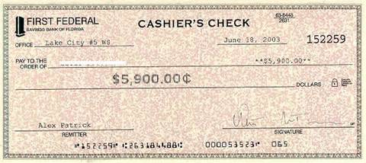
Pink’s Dad:i don't understand why they're
forcing you to choose between the piccolo
and the oboe.You show so much promise with
both.
Pink’s Brother:They say they can't have any
switching between woodwinds because no
matter how divided up, someone would be
left out.
Pink’s Mum:Well, rules are rules, I guess.
Pink’s Dad:Sure, rules and rules.l'm all for
that.But l'm telling you, you really shine on
that oboe.You have real talent, and l'm not
just saying that.
Pink’s Brother:Thanks.
Pink’s Mum:What about Mr.Pemberton? Is
he giving you enough individual attention?
Pink’s Brother: l'd have to say so.He tries to
talk to each one of us at least once during
every practice.
Pink's Mum:That's good.Feedback's
important,
Pink’s Dad:it's key, I think.Hey, so how was
soccer practice?
Pink’s Mum:i think that was in our backyard.
Pink’s Dad:Who's there? What the hell are
you doing out here?
Pink: Hey, Dad.Hey, Mom.You got new patio
furniture.Right on！ My leg.
patio furniture:庭院家具; right on：表达兴奋的感叹语
关注微信公众号“非主刘”，有更多美语学习和其他精彩内容。

Pink’s Mum:What do you think it could be?
Pink’s Dad: God knows ！Im no expert.l don't
know.Uppers, downers? Your guess is as good
as mine,
Pink’s Mum:i think we should check his
arms for needle marks.
Pink’s Dad:Do we let him stay?
Pink’s Mum:The Presbyterian Church has
those meetings.So maybe on condition, you
know? If he agrees to attend? I just don't
know what to teII Jake．
Presbyterian Church:长老会，长老教会是基
督更正教的一派，他们的根源就是苏格兰教
会，美国的长老会就是从苏格兰移民到美国
的那些移民的教会
Pink’s Dad:Good evening.
Pink’s Mum:Well, sleep well?
Pink:What time's, uh What time is dinner?
Pink’s Mum:ln about an hour.You know,
I could wash those clothes if you'd like.They
look a little lived- in.
Pink:No, that's cooI.Maybe later.
Pink’s Dad:We are not doing this again.
Pink’s Mum:Adam
Pink’s Dad: No.We said we'd lay down the
law, we lay down the law.We just have to be
consistent about it.
Walt:You're not taking the bus? All right, well,
listen.Give me maybe another 20 minutes and
we'II get out of here.
Walt Junior:AII right.
Walt:AII right,Yeah, good.You know, I just
think that things have a way of working
themselves out.
Pink:When did you get this?
Pink's Brother: Last May at the year-end assembly.They gave
me that one, too.The one on the end.
Pink:Environmental Consciousness Award.
What's that mean? You, like, recycle cans and
shit?
Pink's Brother: I contacted the
Albuquerque Journal and asked what
chemicals they use to bleach their paper.They
wound up writing an article about it.
Pink:Right on, little bro! Making mad
in-roads with the business community.All
right! Now, hey, remember, not all learning
comes out of books.Look at you.We should
hang out more often.You know, just just kick
back and chill. I mean, if you ever, like, I don't
know, need advice.Because, yo, I mean, l've
been through it all. For real. Hey, man, you You play the flute?
Pink’s Brother:it's a piccolo, actually.
Pink:Dude, play some play some Jethro Tull.

Pink’s Mum: Hey, guys.How we doing in
here?
Pink: We're good.
Pink’s Brother:Yeah.Fine, Mom.
Pink’s Mum: Well, that's good.That's That's
great.
Pink:What the hell? You see this? What, am I
some criminal or something? -
Pink’s Brother:Whatever.
Pink:Whatever? What, you think that's okay?
Like, "Oh, we can't let that scumbag"warp
the mind of our favorite son.
Pink’s Brother:" l'm the favorite? Yeah,
right.You're practically all they ever talk about.
Pink:Oh.snap.Awesome.
snap:表示“兴奋”的语气词
awesome:棒极了
Apply yourself:你自己认真点、上点儿心

Combo:Yo, man, it's me.Hey, listen.You know,
that product? You got any more of that?
Pink:Nah, man, okay? I'm done giving out
freebies.You want charity, go ask the
Salvation Army.
freebies:赠品

Combo:No, no charity.l got this cousin, he's
got him some rich friends.These dudes are in
town.They're looking to par-tay.And your stuff
is, like, so sweet.So what do you say? You up
for making some fat stacks? Because They’ll buy everything you got.
Walt:You can't be serious.What the hell are
you doing here?
Pink:Yo,I waited till the bowl buster left.l
mean, no offense.
bowl buster:本意指一坨堵了马桶的大便，
这里喻指Walt的妻子

Walt:Who sent you? You wearing a wire? You
setting me up?
Pink:A wire? You want a wire? I got a
wire.Speak into the mic, bitch! What the hell's
wrong with you? A wire.Jesus
Walt:So who did you tell about
Pink:Nobody.What are you, nuts?
WaIt:Then why are you here?
Pink:I don’t know.To, like touch base.
touch base:试探性地打个招呼，一般指骚扰
电话推销东西，试探你要不要

Walt:Touch base?
Pink:Yeah, youknow what you call a debrief?
Maybe we could, like I thought we could debrief.
Walt:Debrief? Wow, that's that's what you
think we need, to debrief?
Pink: Yeah, after what happened, it just
seems like the thing to do.Kind of, you know,
talk about it.We can't talk to anybody
else.Anyway, that, and I wanted to I wanted
to tell you how much everybody digs that
meth we cooked.Everybody digs the meth we
cooked.Seriously, I got dudes that would give
their left nut for a little more.
left nut:左侧睾丸

WaIt:Great.
Pink:l'm just saying, if you ever saw your way
clear to You know, you and I cooking a little
more.
Walt:Get the hell off my property.
property:财产;不动产

Pink: What? I'm just saying.
WaIt:Go and don't come back.Now!
Pink:AII right.You know what? Four grand.Your share from selling that batch.That's why l'm here.Yeah, that's right.l didn't smoke it all.

Doctor:Non-small cell adenocarcinoma.Stage
3A, which means it's spread from the lung to
the lymph nodes.There's no denying it's very
serious.
adenocarcinoma:恶性腺瘤；lymph nodes:
淋巴结；Stage 3A:相当于中国大夫说的T3
或T4阶段，也就是晚期，扩散到淋巴了
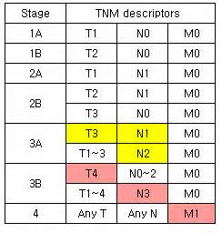
Skyler:But is it It is curable?
Doctor: I prefer the word "treatable." But
the treatments we have at our disposal can be
very effective.Without making any promises, I
can tell you that the specific course of radiation and chemotherapy l'm going to
suggest has been successful.ln certain cases,
it prolonged patients' lives and even resulted
in remission.
Walt:What about the side effects?
Doctor: Well, they can be mild to practically
non-existent, or they can be pretty darn
awful.lt varies from patient to
patient.Typically, there's hair loss, which
begins a couple of weeks after the start of
chemotherapy.You may find yourself
unusually fatigued, not much energy.You
won't want to get out of bed.You may lose
weight due to reduced appetite and certain
intestinal issues.Muscle aches and pains．
gums get sore and bleed.And, of course,
there's the possibility of nausea.Although,
we'II prescribe an anti-emetic and try to
counteract that.Possible kidney or bladder
irritation.You may wind up with increased
bruising and bleeding.There may be sexual
side effects.Your skin may become dry and
irritated
Pink’s Dad:Got anything to say? What do
you know about that?
Pink: Nothing.
Pink’s Dad: That's not going to fly this time.
Pink’s Mum:How many chances have we
given you? How many times have we sat right
here and had the same conversation over and
over again where you look us in the eye and
you plead ignorance, and you play on our
emotions, and you tell us anything you think
we want to hear just so we'II give you another
chance? And it makes us feel like fools, every
time.Enough, Jesse.Enough.
Pink’s Dad: We are not going to have this in
our house.We need you to leave.
Pink’s Brother:Thanks for not telling on me.
You think I could have it back?
Pink:it’s skunk weed anyway.
skunk weed:臭味很大的大麻
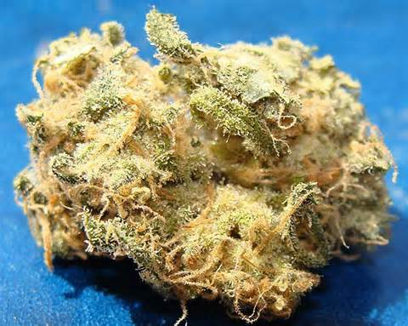

Skyler:You know, this is actually very
hopefuI.Did you hear me? I said this is really
very, very hopefuI.So Can I call them and tell
them you'II start next week?
Skyler:There's a way, Walt.There's financing,
there's installment plans.l could always go
back to work.Walt, there's always a way.
installment plans:分期付款

Walt:AII right.Skyler, say that there is a
way.And we spend all that money, and Am
I supposed to leave you with all that debt? No
honey I just don't want emotions ruling
us.Maybe treatment isn't the way to go.
Walt Junior:Then why don't you just fucking
die already? Just give up and die.
Guy:Come on, move your ass.What do I care?
Yeah, l'm not worried.l have the best fucking
attorney.l would not want to be on the other
side of this one What the hell? What are you
doing? Call somebody, call the fire people.l
don't believe it.You know how much I paid for
that? Why is it doing this?
请扫描下方二维码，关注公众号“非主刘”，有更多美语学习和其他精彩内容。

