Breaking Bad 103 script
请扫描下方二维码，关注公众号“非主刘”，有更多美语学习和其他精彩内容。


Walt:Let's break it down.Hydrogen.What
does that give us?
break down:把…分类Hydrogen:氢元
素
Gretchen: By mole? We're looking at 63%.
mole：摩尔（指原子和分子的数量，1摩尔=（约6.02×10^23个）
Walt:63%,That is a big bite.My next step's
gotta be oxygen.
bite:本意是“咬一口的量”，这里喻指一部
分

Gretchen: Oxygen:26%.
Walt:There you have your water.
Gretchen: Carbon:9%.
Walt:Carbon: 9.
Gretchen: For a total of 98%? -
WaIt:Right.
Gretchen: Nitrogen:1.25%.
Nitrogen：氮

WaIt:1.25.
Gretchen: That brings it to 99 and a quarter.Which only leaves you with the trace
elements down where the magic happens.
trace element:微量元素
Walt:Oh, wait a minute.What about calcium? Calcium's not a trace.Got a whole skeleton to account for.
calcium:钙；skeleton:骨骼；account for:
占…比例

Gretchen: You would think, right?
Walt:Right.
Gretchen: Calcium.Calcium is only 0.25%.
Walt:What? That low? Seriously? Damn,
never would have thought that.Okay, so
where does iron fit in?
Gretchen: lron.Wow,okay.0.00004%.
Walt:What? You can't have hemoglobin without iron.
hemoglobin:血红蛋白，血红蛋白是高等生
物体内负责运载氧的一种蛋白质，也就是人体呼入氧气，通过血红蛋白运输到全身，代谢出来的二氧化碳通过血红蛋白输出到外界。它是使血液呈红色的蛋白。血红蛋白由四条链组成，两条a链和两条8链，每一条链有一个包含一个铁原子的环状血红素。氧气结合在铁原子上，被血液运输。

Gretchen:Apparently, it don't take much.
WaIt: No, it don’t.Go figure. Sodium.
go figure:-句承上启下的俚语，承上是指对
匪夷所思的事情的感叹，启下是下一步还要将其搞明白
sodium:钠

Gretchen: Sodium:0.04.Phosphorus:0.19
phosphorus:磷
Walt:.0.19,There we go.So, the whole thing
? adds up to 99.888042,We are 0.111958% shy.
shy:数额不够

Gretchen: Supposedly that's everything.
WaIt:i don't know.l just I just Just seems like
something's missing, doesn't it? There got to
be more to a human being than that.
Marie:i hate these shoes.These shoes make
me look like I should be changing bedpans,
like I should be squeaking around bringing
soup to some disgusting old person, then take
the bus home to my 16 cats.
bedpans:便盆; squeak :尖叫;瞎 BB

Walt Junior:Then why are you wearing
them?
Marie:l like the support.My arches happen
to be extremely archy.
support：这里指arch support-足弓垫；arch:
足弓
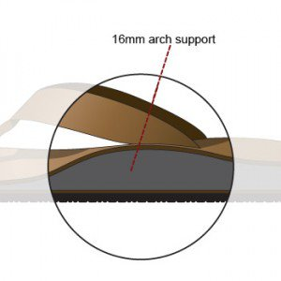

Walt Junior:Yo.What's up? Hey, can you call
me, like, in two minutes? Thanks.Bye.Gotta go
take this.
Skyler:Female?
Walt Junior:Louis.Not like it's any of your
business, though.
Skyler:Just be quick about it.Oh, and, um,
please don't say yo.You can't know how much
I hate that.
Marie: You missed a spot right there.Should you be up on that ladder?
Skyler:You're more than welcome to take over for me up here.
take over:接管

Marie: I don't see why you don't just get
Walt to do it.
Skyler:Yeah.There's an idea.So, l'm working
on this new short story, and there's this
stoner character in it, and l'm trying to Well,
know you, actually, let me back up.You've
smoked your fair share of pot in college,
didn't you? I mean, you at least tried it.Come
on.
stoner:吸毒的人;back up:证实

Marie: I perhaps tried it.Why?
Skyler:Do you rember it having an effect on
your mood, like changing it in any major way,
or
Marie: It made me more serious.
Skyler:Really? Because I mostly remember it
made me light-headed.That's about it.l was
just wondering if it maybe could You know, it's
just a character thing l'm stuck on.Never
mind.
light-headed:头晕的:飘飘然的
Marie: Walter Jr.'s on pot?
Skyler:What? No! No.What would make you
even
Marie: Where's he getting it from?
Skyler:Marie.
Marie: Seriously.ls it this Louis person? What
are you going to do about this?
Skyler:You need to look me in the eye.l am
strictly asking about a story that I am writing,
that's aII.Right hand to God, Walter Jr.is not
on pot.Certainly not as far as I know.
Marie: Not as far as you know?
Skyler:Marie.
Crazy-8:Look at me.Hey, turn around and look
at me.This This here I wouldn't do this to my
worst enemy.This is degrading.
degrading:可耻的

Walt:.l'm sorry.
Crazy-8:You hope l'II make it easy on you and
just drop dead, don't you? Well, I won't.So
either kill me or let me go.You don't have it in
you, Walter.
Walt:How do you know my name?
Crazy-8:Jesse.He told Emilia and me.When he
came by to sell your meth?
Walt:.So what? You threaten him, huh? - Did
you beat it out of him?
Crazy-8:Not even close.
Walt:.What else did he tell you?
Crazy-8: Pretty much everything you can think
of.How you were his high school teacher.How one time you taught about carbon dioxide by making grape soda in class.How you have a son who's retarded, or in a wheelchair or something.This shouldn't come across as some news flash.That partner of yours he's got a big mouth.Walter, I don't know what you think you're doing here, but trust me,
this line of work doesn't suit you.
retarded:弱智的；news flash:突然插播的重
大新闻；line of work:行当

Walt:.So I should just let you go, then? Just
unlock you and adios huh?
adios:（西班牙语）再见

Crazy-8:I don't see what real choice you have
if it's between that and cold-blooded murder.
Besides your real problem is sitting upstairs.
Pink:Occupied! Hey, yo, l'rn trying to pinch
one off in here! Just give me some privacy,
would ya? What the hell, man? What are you
doing, man? - You assholel
occupied:使用中的；pinch one off:努力挤
出大便
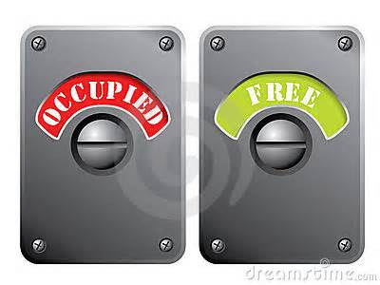
Walt:You told him my name.
Pink:Says who? Him?
Walt:My name, where I work.You told him
about my son!
Pink: Don't touch me!
Walt: Damn junkie!
junkie:瘾君子

Pink:No, give me that!
Walt:Too late! This is going down the toilet! Get off the toilet!Watch it gol
Pink:No, that's worth 40 grand, you stupid shit.
Walt:lt's worth nothing when you smoke it
aII.Get off the toilet.Get off the toiletl Get off
the toilet!
Pink:stop itI
Walt:Nol No way! What the hell do you think
you're going?
Pink:Back off, man! Jesus!
WaIt:We've got work to do!
Pink:No, you got work to do.l did my part.
Walt:You mean that obscenity that I spent
the last two hours cleaning up? That is your contribution?
obscenity:污秽

Pink: Yo! Kiss my pink ass, man! I didn't ask
for any of this! How am I supposed to live
here now, huh? My whole house smells like
toe cheese and dry cleaning.
toe cheese:脚趾与脚趾之间的泥（脏东西），
天津话叫“脚卡巴”
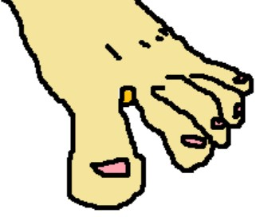

dry cleaning:干洗，这里应该喻指干洗剂

Walt:Because you didn't follow my
instructions!
Pink:Oh, well, hail Hitler, bitch.And let me
tell you something else.We flipped a coin,
okay? You and me.You and me! Coin flip is
sacred.
hail Hitler:希特勒万岁；sacred:神圣的

Pink:Damn it.Your job is waiting for you in
that basement, as per the coin.Fucking do it
already.
per:按照
Shop Assistant:That's what she said.Yeah, I
think we have some of those.Yeah, you'II have
to try them on.
Marie: Hello.
Shop Assistant:7 and a half, maybe.l don't
know.
Marie: Excuse me.Do you have these in
black?
Shop Assistant:Anyway, so like I was saying,
I went to the party the other night.Yeah, Tony
was there.
Marie: Hey, where have you been? I called
you two hours ago.
Hank:Sorry, baby.l'm kinda busy here.What's
up?
Marie: Kind of a lot, actually, and it's a
delicate subject, so I need you to focus and
delicate：微妙的;精巧的

Hank:Hey, sit down! Sit downl
Marie: Damn it, Hank.
Hank:Well, sorry, babe.l'rn just l'm kind of in
the middle of something here.Sit downl Sit
your ass down! Comprendio? You, too! Sit
down! sientate! I'm back, baby.What's up?
Comprendio:（西语）=understand明白吗？
sientate=sit down:坐下

Marie: Walter Jr.
Hank:Yeah, what about him?
Marie: Marijuana.He's smoking it.
Hank:Bull shit.
Marie: Excuse me.His own mother seems to think so.Skyler told you that?
Marie: She inferred it.
Hank:She inferred it, huh?
Marie: She strongly inferred it, like "Doctor,
my friend suffers from erectile dysfunction.
" Please, come on already.l want you to talk to
him.
erectile dysfunction:勃起障碍

Hank:Walt should talk to him.Skyler, better
yet.She'II kick his butt up and down the block.
Marie: I think it ought to be you.You know,
tell him some horror stories.Maybe show him
some autopsy pictures.
Hank:What, autopsy for a pot overdose? Come on.l don't know, baby.lt's just that, you know I figure his dad should be the one doing
this thing, don't you think?
autopsy:验尸; pot:毒品; overdose:服药过量

Marie: Hank, he respects you.
Hank:Yeah, all right.Well, listen,I’ll swing by
their place after work.
swing by:顺便拜访（天津话：打一晃）

Marie: Good.Scare him strailght.
Scare him straight:教育犯错的年轻人，以
便他们不会进监狱

Hank:Where's my sugar?
Shop Assistant:Excuse me, ma'am.Ma'am.
You need to be wearing footies before you try
those on.
footies:试鞋前要穿的袜子，类似中文的“船袜”
关注微信公众号“非主刘”，有更多美语学习和其他精彩内容。

Marie: l'm extremely clean.
Shop Assistant:Yeah, well, l'd really appreciate it.Hey, sorry about that.Yeah, l'll
check.You know, I hid a pair for you last week,
gray ones, but my manager found them, and
we had to put them back on the floor.
Hank:What do you think?
Walt Junior:About what?
Hank:This look like a nice place?
Walt Junior:No, not really.
Hank:Think you'd like to live here?
Walt Junior:No.
Hank:You sure about that?
Walt Junior:Yeah, pretty sure.l thought we
were going to Cold Stone Creamery.
Cold Stone:酷圣石(卖冰激凌的地方) ;creamery:奶油商店
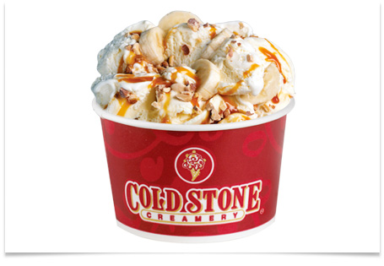
美国COLD STONE Creamery公司坚持商品
高质量与口味的多元创造性，结合欢乐的服务方式，经营冰淇淋事业。自1988年在美国亚利桑那州开设第一家门市，目前版图已横跨全球17个国家，达1，725余家门市。
2006年12月28日正式授权台湾统一超
商，经营最优质、顶级新鲜现做的冰淇淋品牌，成立酷圣石冰淇淋股份有限公司，
第一家COLD STONE门市于2007年4月30日开幕！酷圣石冰淇淋股份有限公司是美国COLD STONE Creamery继日本、韩国后，第三个海外授权国家。至今，COLD STONE已进军日本、南韩、中国、台湾与东南亚、墨西哥及迪拜等地。天津的酷圣石如果办完会员卡，周二的时候买一杯赠一杯（或半价）
half lives．（人人影视和搜狐视频字幕给错）
Hank:Well,a little detour.Figured we'd come
over here and check out how the other half lives.This here's what we call the Crystal
Palace.Now you know who lives in the palace?Meth-heads.Nasty,skeevy, meth-heads who'd sell their grandma’s coochie for a hit.Oh, you think that's funny? That's funny, huh?Yeah.Well, let me tell you something.
Every last one of these miserable wastes of skin got started how? - How do you think they got started?
detour:绕道； how the other half lives:
可译为“另一个世界的人怎么活着的”
nasty:龌龊的；skeevy:恶心的；meth-heads:
吸冰毒的人，瘾君子；coochie:阴道；hit:
大麻烟；Every last one:（强调）每一个人；
wastes of skin:废物
Walt Junior:l don't know.
Hank:What do you think it was they were all
doing before they graduated to shooting meth in their dicks?A gateway drug.That's what we call it.Dollars to doughnuts, and I shit you not, that gateway drug was marijuana.Every time. You understand?
dick:生殖器；gateway drug:入门诱饵毒品（诱导毒虫进一步吸更厉害的毒）
dollars to doughnuts:十拿九稳的事；
shit younot:确定无疑的告诉你

Walt Junior: Um, yeah.So why are you
telling me this?
Hank:Cause I love you, you little bastard.Hey,
I was young once, you know? The world's a
messed up place, you know? You know, there
was this this one time when
bastard:王八蛋

Hank: Hey! Hey! Hey, you! Yeah, you,
Princess!Get over here! Don't make me get
out of the car! Check this out.See what l'm
talking about.
Wendy:l ain't holdin’, okay?
ain't=am not;is not;are not
hold:持有想要卖的毒品
Hank: Did I say you could open your mouth?
And hands of the car.Other side.Go around
the other side.Talk to my friend here.What's
your name, sweetheart?
Wendy: Wendy.
Hank: Wendy, huh? How much you charge
for a windy, Wendy?
charge:要价; windy:口交

Wendy:i ain't doing him.He's a kid.
Hank: Jesus, was that my question? Don't
think so hard.lt's gonna hurt your brain.Are
you on the pipe or the needle?
Wendy:Nothing.Neither.
Hank:Show us your teeth, huh? Come on,
Wendy, let's see those pearly whites.Oh, God.
See that? Pipe.Definitely.Big time.Big time on
the pipe.You got something you wanna ask
Wendy?
big time：极有可能

Walt Junior: No, not really.
Hank:You ever smoke anything else, Wendy?
Sausages don't count.Seriously.Tell my friend
here how you got to be, what, like,started.You probably used a Girl Scout - or probably sang in a church choir?
girl scouter：女童子军（《老友记笔记书》中
详细介绍）
church choir:教堂唱诗班

Wendy:What are you, like, handicapped?
handicap:残疾
Hank:He broke his leg playing footbaII He's a QB.Got an arm like a howitzer.So tell me,
Wendy, do you smoke pot?
QB: Quarterback是美式橄榄球和加拿大式
足球中的一个战术位置。四分卫是进攻组的
一员，排在中锋的后面、进攻阵型的中央。
他通常是临场指挥的领袖，大部分的进攻由他发动，并有责任在大部分的进攻前发出暗号。 四分卫通常是除了中锋以外第一个接触球的人。接到中锋发球后，他可以递传、抛长传给跑卫、近端峰和外接员，或自己持球冲锋。传球和冲锋都擅长的四分卫通常被称为双料四分卫(dual-threat quarterback)
howitzer:榴弹炮
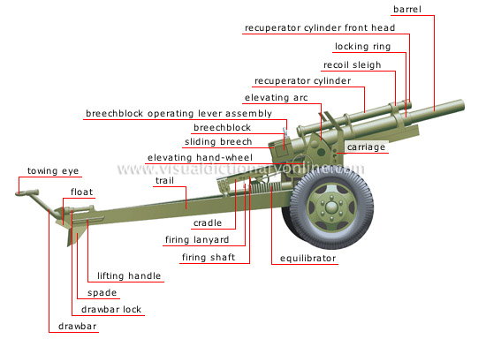
Wendy:Why, you got some?
Hank:All right. Hoof it.Get lost.Get out of
here.Hey, fair warning! Next time l'm gonna
bust you! So what do you think?
hoof it：走；get lost：滚蛋；fair warning:事先警告一下；bust:逮捕

Walt Junior: Cool.
Pink:Shut the door.Lock it.Lock it.Who the
hell was that?
Wendy:A cop and some football player
messing with me.
mess with：拿…找乐、寻开心；插科打诨

Walt Junior:They ask about me?
Wendy:Huh? No.l think they just wanted pot.Oh, shit.l left my root beer.
root beer:沙士啤酒；根汁饮料，作为饮料以
黄樟油、冬青油为香料的碳酸饮料，作为酒，
是低度数的
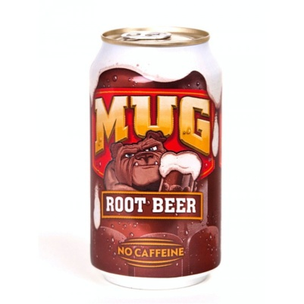

LET HIM LIVE IT'S THE MORAL THING TO DO
WON'T BE ABLE TO LIVE WITH YOURSELF
MURDER IS WRONG! KILL HIM, HE'LL KILL
YOU ENTIRE FAMILYIF YOU LET HIM GO
Skyler: Hello.
WaIt: Hey, sweetie, it's me.Listen, l'm so
sorry.The time, it just completely got away
from me there.My fault.My fault.Bogdan just
kept me here late, you know, doing some
inventory, and l've I should have just You
know, you're right.l gotta learn to say, you
know, no! But, um Sky? You there?
Skyler: You're at the car wash?
WaIt: Yeah.
Skyler:I seriously doubt that, since you quit
two weeks ago.l called Bogdan, looking for
you.Quite an earful he gave me.
Walt : Listen Listen, l'll come home, and
we'II talk about it.
Skyler: I don't think so, WaIt.
Walt : Honey,
Skyler: Wherever you are why don't you just
stay there tonight?
WaIt: Skyler? Skyler? Skyler?
Crazy-8:Walter! Kind of hungry down here! Damn.l didn't think you were coming back.
WaIt: How long was I out?
Crazy-8: 10,15 minutes.l've never seen
someone knock themselves out just by
coughing.You breathe in the same thing you
used on me?
WaIt: l've got lung cancer.l'II go make you
another sandwich.lt's safe.There's no poison.
Crazy-8:Yeah? Because that'd be the way to
do it if you're gonna do it.
WaIt: l suppose it would.
Crazy-8:1 mean, you being a chemist and all.
WaIt: So that name Krazy-8 Do I really have to call you that? l mean, no offense, but don't you have a real name?
Crazy-8:Domingo.
WaIt:Domingo.That's "Sunday,” right? I'd
rather call you that, if you don't mind.
Crazy-8:Yeah, whatever.l can't say I ever liked
it much.
WaIt:So, Domingo are you from around
town here or someplace else?
Crazy-8:Walter, you getting to know me is
not gonna make it easier for you to kill
me.Not that I mind, you understand.
Not that I mind:倒不是说我介意什么
关注微信公众号“非主刘”，有更多美语学习和其他精彩内容。

WaIt: You know, you keep telling me that I
don't have it in me.Well, maybe.But maybe
not.l sure as hell am looking for any reason
not to.l mean, any good reason at aII.Sell
me.Tell me what it is.
Crazy-8:1 guess l'd start off by promising that,
if you let me go, I won't come after you.That
you'd be safe.l guess l'd say what happened
between us never happened.And what's best
for both parties is we forget all about it.But
you know that anybody in my situation would
make promises like that.And though in my
case they happen to be true, you'd never
know for sure.So what else can I tell you?
WaIt: l don't know.But you gotta convince
me.And you're going nowhere until you do.
Crazy-8:Hey, yeah.Yeah.l'm from here in
town,man.ABQ.Born and bred.Never
left.Studied business administration over at
UNM, got my degree.
ABQ:阿尔伯克基Albuquerque是美国新墨
西哥州在人口上最大的城市，位于新墨西哥
州中部地区、横跨格兰德河(Rio Grande)
的两岸，在2011年的人口上升约为55万
2804人，整个都会区的人口则为90万1?00
人。阿尔伯克基于2012年时名列全美国第
32大城市．新墨西哥大学(University of
New Mexico，UNM)、科特兰空军基地(英
语：Kirtland Air Force Base) (Kirtland Air
Force Base)、桑迪亚国家实验室(英语：
Sandia National Laboratories) (Sandia
National Laboratories)、与石化森林国家纪
念物(英语：Petroglyph National Monument)
( Petroglyph National Monument)都位于阿
尔伯克基。
business administration:工商管理
UNM:新墨西哥大学;bred(breed过去式)：培育；养育

WaIt:Really? Does that come in handy in the
drug trade?
Crazy-8:lt doesn't hurt.l was gonna study
music originally.Maybe even try out for
Oberlin or Berklee.My pops talked me out of it.Said there was no money in it unless I wind
up some bullshit rock star, and I didn't have a
snowball chance of that, man.
Berklee:伯克利音乐学院，位于马萨诸塞州，波士顿，是全世界最大的现代独立音乐学院。音乐学院一直独树一帜，是美国外国学生比例最高的学院之一。欧美许多已经成名的音乐家也常来此进修，以感受现代音乐发展的脉搏。
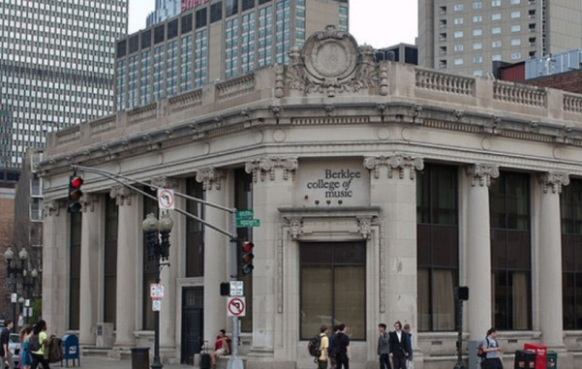
WaIt: What does your dad do?
Crazy-8:He owns Tampico Furniture over on
Menaul.
WaIt:Wait a minute.l know that place.Wait a
minute.That's That's that They used to have
those late-night
Crazy-8:Those stupid commercials.Yeah
Crazy-8:that's him. He's been doing 'em for
over 30 years.
WaIt: Wait a minute.How did it go? It was,
uh Wait, wait, wait.lt was Don't let shopping
Strain your brain-o Just sing this short refrain-o Our forniture is bueno Tampico is the name-o.
Crazy-8:Pretty moronic.But what can you
do?
WaIt: it did tend to stick in your head.Did
you write that, being the musician of the
family?
Crazy-8:Hell, no, man.lt was my crazy Uncle
Alex.He sings it at bars, trying to pick up on
women.ln his mind, it's like saying, "I wrote
Stairway to Heaven．¨
WaIt:Wait a minute.Tampico Furniture.l
think when my son was born that we bought
his bassinet there.
Crazy-8:We don't sell bassinets there.more of a specialty item. We did use to sell cribs.
Walt : Oh.Well, a crib, then, okay? Crib.Yeah.No, I remember that.ln fact,
remember recognizing your dad from those
commercials.Although he wasn't anywhere
near as friendly in real life.
Crazy-8:Yeah, no shit.Did he try selling you
that extended warranty?
WaIt:Yeah, he probably did.And I was
probably dumb enough to buy it.
Crazy-8:Yeah, that was his big thing.You ask
him for a glass of water, he'II tell you you
need an extended warranty on the ice.
WaIt: So did you work there, too?
Crazy-8: Only my whole life, up until the day
I said "fuck you" and quit.
WaIt: So, 16 years ago,how old would you
have been?
Crazy-8:lt was after schooI.Trust me, I was
there.Might have even helped ring you up.
You and your extended warranty on the crib.
WaIt:Small world.
Crazy-8:That it is.
WaIt: The paths we take, huh? you like?
Crazy-8:You Jesse know you got cancer?
WaIt: No one but you.
Crazy-8:Not your family?
WaIt:No.
Crazy-8:Why not?
WaIt: Not a conversation l'm even remotely
ready to have.
remotely ready:(remotely．根本用于否定句，表强调)远没准备好

Crazy-8:That's why you're cooking meth?
You want to leave money for your family.Hell,
I'II write you a check right now if you let me
go.Like I said, Walter, this line of work doesn't
suit you, man.Get out before it's too late.
WaIt: I don't know what to do.
Crazy-8:Yeah.You do.
WaIt: I'II get the key.No, don't do this.Don't
do this.Why are you doing this? Why are you
doing this?
Crazy-8: You're doing the right thing, Walter.
WaIt: Do you want to So you're not angry?
Crazy-8: How do you mean? Angry? No.Live
and let live, man.
WaIt: That's very understanding.
Crazy-8:Whatever, man.l just want to go
home.
WaIt:Me,too.
Crazy-8:Unlock me, Walter.
WaIt: The moment I do are you gonna stick
me with that broken piece of plate? I'm
sorry.l'm sorry.l'm sorry.l'm so sorry.
Pink:Hello? Anybody down here?
Carmen:Everybodyl I need you all to take
your seats.Settle down, please.Thank you.l
understand that Mr.White is feeling a little
under the weather this morning, so you folks
are going to have to be making do with me
today.And we are going to be watching a very
interesting video on carbon.Very important
stuff.
Gomez: So what do you think? -
Hank:it's a cook site.Gotta be.Nobody came
way the hell out here just to buy.Fire there
could have started by accident.Don't look like
it was meant to destroy evidence.
Gomez: Got a couple of Dually tracks headed
away towards the road.So, what, they're in
some kind of camper lab.They accidentally
start a fire, and everybody F.O.'s?
Hank:Yeah, why not? Except why would that
little hair-gelled shit leave his car? I-yi-yi,
Gomie! It's a culture in decline.
Gomez: lt's a rich and vibrant culture.
Hank:it's a car that jumps up and down.What
the hell? You people used to be conquistadors,for Christ’s sake. Smells like a Drakkar Noir factory in here（人人影视、搜狐视频中文字幕给错）．
conquistador:征服者（是在16至17世纪征服了新大陆广阔土地的西班牙军人和探险家。这些轻装的西班牙骑兵已经在驱逐摩尔人的战争中久经历练）

Gomez:I already searched it.You're wasting
your time.Give it up.lf this here‘s a trap
car(人人影视搜狐视频给错中文翻译)，it's gonna take more than your dumb white ass to find it．
trap car:重色彩，大边缘的车，一般是毒品
贩子开的

Hank:You are talking to the trap car master,
my friend.l'm Rain Man counting his
toothpicks.
rain man:《雨人》，1988年老片，达斯丁霍
夫曼与汤姆克鲁斯主演，其中主角雨人是一
个患有自闭症的天才
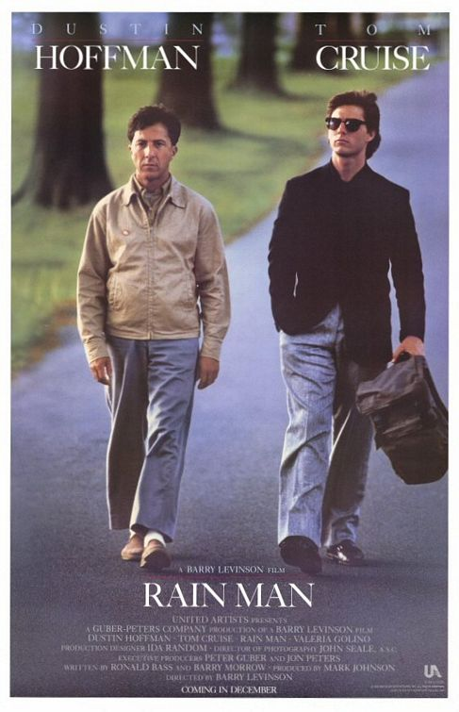

Gomez: Yeah, you're like Rain Man.Retarded
Hank:Yeah, baby. Hello, Zippy.
zippy:毒品

Gomez: Asshole!
Hank:l'd say that looks like meth, but it's it's
too damn white.You know what l'm thinking,
Gomie.
Gomez: Somebody croaked our snitch
Police:Hey, agents!
Hank:You got something?
WaIt: I don't know.Just Doesn't it seem like
something's missing?
Gretchen: what about the soul?
Walt : The souI.There's nothing but
chemistry here.Skyler.There's something
I have to tell you.
请扫描下方二维码，关注公众号“非主刘”，有更多美语学习和其他精彩内容。

